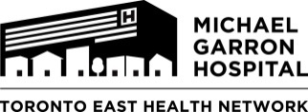
Rapid Access Addiction Medicine (RAAM) Clinic-
Referral Form

Clinic Hours until November 1 2019:
8:45-11am Tuesday and Friday, 12:45-3pm Thursday
Clinic Hours from November 4 2019 onward:
8:45-11am Monday and Tuesday, 12:45-3pm Thursday

Patient Label

The MGH RAAM clinic is staffed by an interdisciplinary team of a physician, nurse and counsellor. It provides outpatient addiction-related medication and counseling treatment as well as community referrals.

To ensure continuity of care, please fax this referral to 416-469-6221.

Patients may drop in during clinic hours and we can also make an appointment for them. Would you like us to contact the patient to make an appointment? YES NO (please circle)

Please ask patients are to register at the Admitting Department, First Floor, Michael Garron Hospital.

Patient Last Name: | Patient Given Name: | DOB: (Day/ Month/ Year)
Address: | Town/ City: Prov: | Postal Code:
OHIP: | Version Code: | Telephone #:
Date of Referral: | Referred By: | Family Physician:

Short description of addiction issues:

Past Medical History:

Medication list:

***Though we try our best to reduce wait times at clinic, please inform patients that they may have to wait to see a physician****

SP-936 (Rev.2019) Forms WG Approval Date 03/2018

