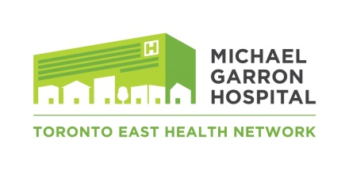

Research Ethics Board

External Research Notification Form
This form is to be completed by local MGH Investigators conducting external research to ensure that Michael Garron Hospital and the Research Ethics Board are informed by you of any external research that you as an investigator have instituted and are conducting outside of MGH that you should receive acknowledgement for.
SECTION 1 – Study Identification
Full Study Title:
SECTION 2 – Contact Information
Local MGH Principal Investigator:
Department / Division / Program:
Telephone:
Email Address:
Name of Person Completing the Form & Role:
Address:
Telephone:
Email Address:
SECTION 3 – Brief Summary of Study
SECTION 4 – Funding
Funded Not Funded
If Funded, Source of Funding:
Amount:
SECTION 5 – Provide Details of Where the Study is Taking Place
SECTION 6 – Comments / Notes
SECTION 7 – MGH Local Principal Investigator Signature
Print Name |  | Signature |  | Date (dd/mmm/yyyy)

Return to:
Research Department
Michael Garron Hospital Toronto East Health Network
825 Coxwell Avenue, Room C424, Toronto, ON, M4C 3E7
Phone: 416-469-6580 Ext. 3853
Email: ResearchEthicsBoard@tehn.ca

