BREAST SURGERY

DISCHARGE INSTRUCTIONS

□ LUMPECTOMY
□ SIMPLE OR TOTAL
MASTECTOMY
□ MODIFIIED RADICAL
□ SENTINEL NODE BIOPSY
□ AXILLARY LYMPH NODE
DISSECTION



The information presented is for educational purposes only. It is not intended to replace advice from your health care provider.

Breast is composed of ducts, lobules and tissue fat with lymph nodes and channels. Muscles are behind and under the breast for support and movement.

A lump is most often located in the upper, outer quadrant of the breast. This is where the most granular tissue is found.

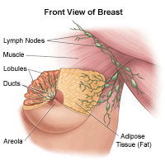

(1)

□ Breast Lumpectomy

Removal of the entire tumor and part of the surrounding breast tissue to ensure surrounding areas are clear. Axillary lymph nodes are either completely removed or biopsied. (See later)

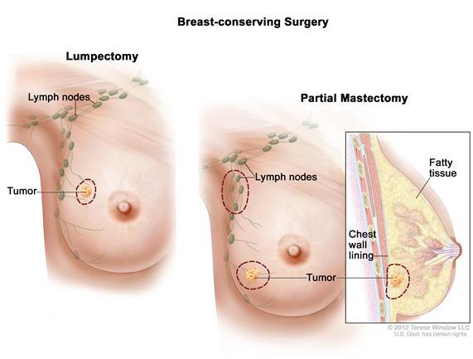

(2)
□ Simple/Total Mastectomy
Removal of breast tissue; lymph nodes and muscle is left in place.

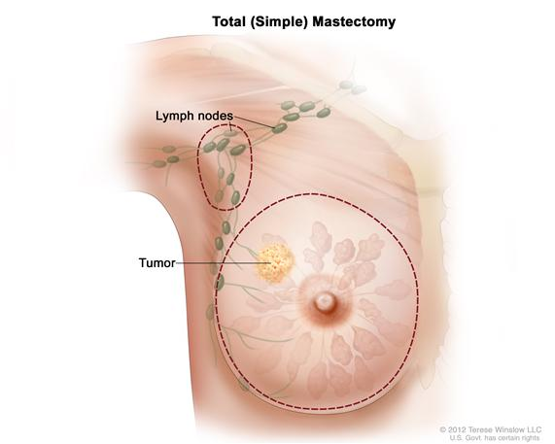

□ Modified Radical Mastectomy
Removal of all breast tissue and the axillary lymph nodes. The muscle is left in place.

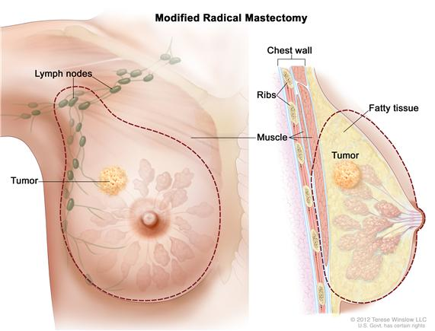
(3)
□ Sentinel Node Biopsy
Removal of a few nodes, which are usually tested for cancer cells. This is done at same time as your breast surgery. If the surgeon injects a blue dye during surgery it may cause your urine and stool to be a bright or blue green in color for a couple of days. The skin around the incision may also be bluish in color and may take a few weeks to completely disappear.

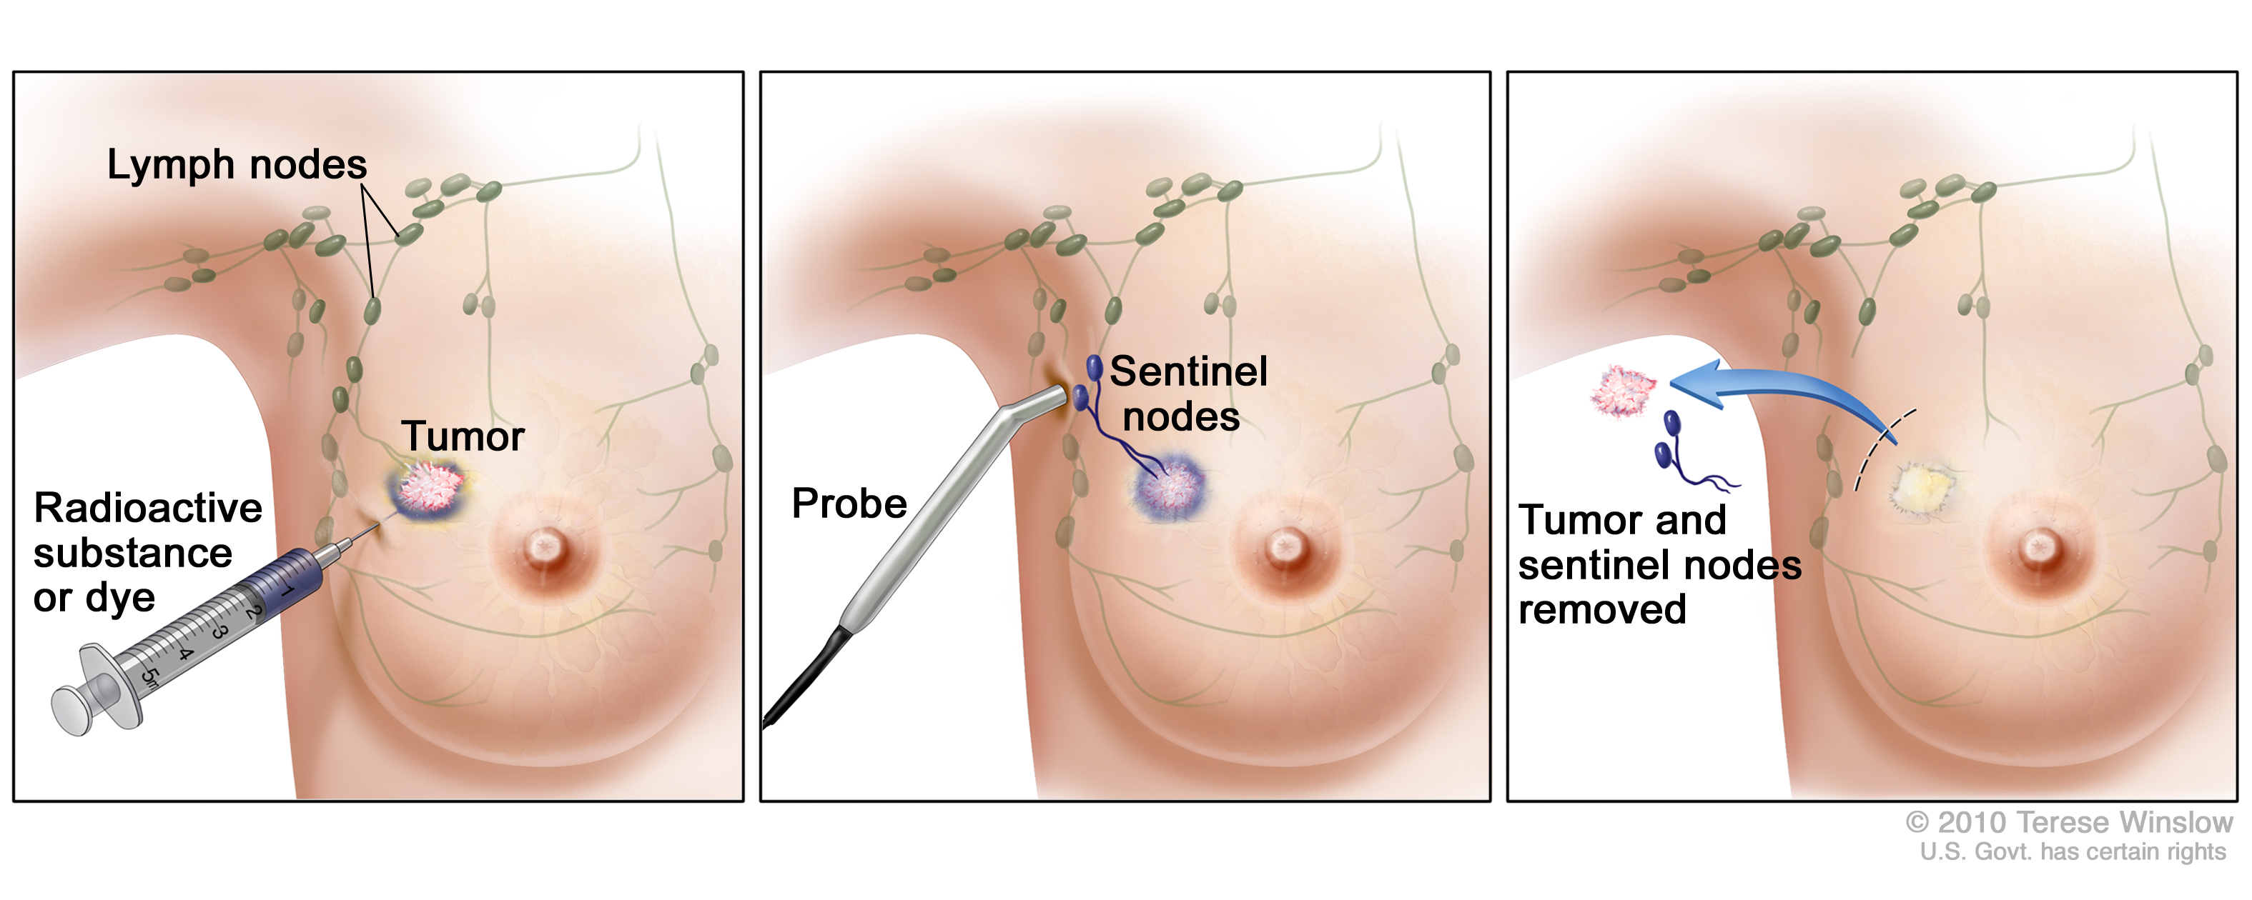

(4)

□ Axillary Lymph node dissection
Removal of lymph node from the axillary (armpit) on the same side the cancer was identified. This is done at the same time as your breast surgery.

You may have some numbness or tingling in your arm or armpit due to the cutting of nerves. Stiffness, discomfort of shoulder or arm will improve over time and exercise.

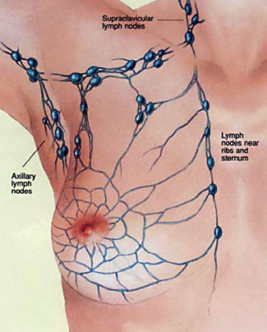

(5)


DIET:
- No diet restrictions, but it is always a good idea to
eat a well-balanced diet and include lots of fruit and vegetables
- Drink plenty of fluids


ACTIVITY:

- It is normal to feel tired after your surgery. Plan regular rest periods
- No strenuous activity like vacuuming or mowing the lawn. No contact sports
- Walking is a normal activity; can start after surgery
- Shower before exercising helps to loosen muscles
- After lymph node dissection do not avoid using the arm; no strenuous activity until you see your doctor
- If you have a drain- no driving until after the drain has been removed
- NO DRIVING until normal range of motion to affected arm has returned

(6)

PAIN:
It is not NORMAL to have severe pain

- Take your prescribed pain medication as ordered by your surgeon
- DO NOT wait until the pain is severe before taking the pain medication
- Take your pain medication 30 minutes before planned exercise and at bedtime
- Each day your pain will be less and less requiring less pain medication
- Moderate elevation of the extremity helps to decrease tension on surgical incision and promotes circulation and prevents venous congestion
- After lymph node dissection use an ice pack to help decrease the swelling in armpit
- Some pain medication causes constipation. Fluids may help as well as prescribed stool softener

WOUND CARE:
- You may shower and pat the area dry. DO NOT apply creams, powder, ointment, deodorants, perfumes, until incision healed
- Do not use herbal remedies without speaking with your surgeon
- May remove dressing after 24hours but NOT the steri –strips ( paper tape)
(7)

- If you have steri –strips over the incision, they will fall off in about 7 to 10 days. Do not pull them off
- If you have staples they are usually removed 7-10 days after your surgery; but check with your surgeon first
- Once drain is removed, keep wound clean by showering daily and patting the area dry
- Avoid tub baths until wound has healed fully
- It is normal to have some swelling and bruising at incision site; this will go away in a few days
- Transient edema in extremity is fairly common; elevate arm above the heart for 45mins three times a day to help promote circulation

NO BLOOD PRESSURE, BLOOD WORK OR INTRAVENOUS (IV) ON
AFFECTED SIDE

(8)
The purpose of your drain is to collect fluid from the surgery site. This helps prevent bruising and swelling. Your drain works by suction. When you go home you will have to empty the drain. A nurse will show you how to do this before you go home.

HELPFUL TIPS AT HOME

- Empty the drain into a container when the fluid collects in the bottom or at least every 8 hours.
- Do not let the drain get too full or it will lose suction.
- The drain needs to be below the surgery site so that it drains well. Secure the drain with a safety pin to your clothes.
- Check your drain often for kinks and/or clots. There should be no tension or tug on the drain or tubing.

TO EMPTY:
1. Wash your hands
2. Unplug the drainage plug
3. Hold the drain upside down and squeeze the contents into the container
4. When it is empty, continue to squeeze the drain and plug the drain back in. Squeezing compresses the drain which causes the suction.

(9)

The drain expands as it collects fluid – as the amount reduces your doctor may order it to be removed by the nurse.
5. Measure the fluid and record the date, time it was emptied and amount for the nurse.
6. Flush the fluid down the toilet.
7. Wash your hands.

MY DRAIN OUTPUT RECORD
Record the amount each time you empty drain
DATE | TIME | AMOUNT

(10)

SEROMA
Fluid that has collected around the incision after your drain was removed. It is most common after a mastectomy. This can cause swelling and pain at the incision area.

This will often clear up on its own. If swelling continues you may need to have the fluid removed.
Notify your surgeon.

HEMATOMA
Blood that has collected around the incision area. This can cause pain, redness and swelling. This will usually clear up on its own. It can take a few weeks to months. Notify your surgeon.

LYMPHEDEMA

Swelling of the affected arm is due to the removal of axillary lymph nodes and inability of the lymphatic system to drain lymph fluid effectively. You may have numbness, discomfort, tightness and sometimes an infection. If this occurs, please notify your surgeon.

(11)

PREVENTION OF LYMPHEDEMA

- Exercise regularly; speak with your doctor first before starting/resuming exercise program like weights
- Gradually increase activity of affected arm
- Maintain ideal body weight; overweight more likely to develop lymphedema
- Wear loose fitting clothing and jewelry
- Do not carry heavy bags or purse on affected side
- Wear sunscreen at all times to avoid sunburns, skin breakdown
- Avoid lying on affected side, elevate arm on pillow

AVOID INFECTION

- Wash hands frequently
- Wear gloves to help protect hands, skin from sores, scratches when doing dishes, housework, gardening
- Use moisturizer daily to prevent skin from becoming dry
- Use an electric shaver when shaving under arm

(12)

What Kind Of Bra Should I Wear?

Lumpectomy
Good support bra; no underwire bras
- May be worn at nighttime
- Cotton sports bra with front closure, less elastic the better, armholes should be cut low

Mastectomy
- Fluffy cotton breast forms can be worn in bra for the first couple of weeks
- Once the wound has healed usually in 4-6 weeks you than can be fitted for a breast prosthesis

Temporary breast form prosthesis can be obtained from the Canadian Cancer Society Peer Support Program. They also have a list stores in your area that carry mastectomy bras. Call 1-888-939-3333 for more information.

The Assistive Device Program (ADP) can assist permanent residents of Ontario with the cost of breast prosthesis. Your private insurance may cover any costs the ADP does not pay for.

Toronto 416-327-8804
Toll-free 1-800-268-6021

(13)

COPING AFTER SURGERY

A diagnosis of breast cancer is a difficult time. Coping with the treatments, side effects, managing your emotions and adjusting to the changes in body image can be very overwhelming.

These feelings are normal. It is important that you look for emotional support through a family member, close friend or from another breast cancer survivor.

You may find it hard to look at your scar right after surgery; that’s okay. It is your choice when to look and touch your scar. You can have someone with you the first time you look.

Give yourself time to adjust to your new body image.

(14)
Exercising After Surgery for Breast Cancer
Exercise is an important part of the recovery process and can help to reduce shoulder and arm pain and stiffness, improve strength and prepare you to resume normal daily activities.

General Exercise Guidelines
- Wear comfortable/loose clothing
- Don’t hold your breath; slow deep breaths are best!
- Exercises should not be painful, exercise only to the point of a gentle stretch
- Be careful not to overdo it, swelling and pain may be signs of doing too much
- Avoid any sudden movements
- It is best to exercise when you are warm and relaxed
- Talk to your doctor before beginning any exercises

Gentle Exercises in the 1st Week after Surgery (or while the drain is still in place)
*Can be done 5-10 times each, 3-4 times per day, starting around the 3rd day after surgery
- Shoulder shrugs: gently lift your shoulders up towards your ears, hold for 5 seconds then relax them back down
- Shoulder rolls: gently roll your shoulders to make small circles moving forward, this can then be repeated making circles backwards

(15)
- Deep breathing: take slow controlled deep breaths in through your nose trying to fill up your lungs, then breath out through your mouth
- Shoulder blade squeezes: with your hands down by your sides gently bring your shoulder blades together and down
- Arm lifts: with your hands clasped together and your elbow pointing out slowly lift your arms up only until you feel a gentle stretch for 1-2 seconds then lower your arms down
Exercising After the Drain Comes Out
It will be important to try to get back full movement in your arm and shoulder. Speak to your doctor/ health care team about moving on to more advanced exercises.
(16)

WHEN YO CALL DOCTOR:

- If you have a fever of 38.0 C or 100.0 F or higher
- Shaking or chills
- Redness, warmth, increased swelling at incision site
- Rash, red blotches or streaks along incision line
- Increase drainage from incision or foul smell from incision
- Incision edges may open up
- If color of drainage changes; e.g. pink to red
- Increased pain which is not relieved by your pain medication
- Any nausea or vomiting which does not go away in 2 days
- Swelling to arm, hand, chest wall and neck
- Feelings of depression or anxiety
- Drain issues ( if applicable) and not resolved by homecare nurse; example: leakage from around the drain, blockage, etc


(17)
QUESTIONS FOR YOUR DOCTOR:

____________________________________

____________________________________

____________________________________

____________________________________

____________________________________

____________________________________
____________________________________

____________________________________

___________________________________

If you have any questions regarding your surgery, please contact your surgeon

(18)

RESOURCES:
BOOK
Dr Susan Loves Breast Book 5th edition

Websites
Canadian Cancer Society
1-888-939-3333
www.cancer.ca
Canadian Breast Cancer Network
1-800-685-8820
www.cbcn.ca/en
Guiding Women through a breast cancer diagnosis; a supportive personal approach

https://breastnorth.info/Portals/7/Guiding_Women%20through%20a%20br%20ca%20dx.pdf

Well Spring
https://wellspring.ca
Willow Breast Cancer Support
www.willow.org
Look Good, Feel Better Canada Foundation
905-890-5161; 1-800- 914-5665
www.lgfb.ca
Cancer Care Ontario
416-971-9800
www.cancercare.on.ca
(19)
Rethink Breast Cancer
https://rethinkbreastcancer.com/support-and-the-city/

BC Cancer Agency British Columbia
www.bccancer.bc.ca

BC Cancer Agency: Getting Ready for Breast Cancer Surgery
http://www.bccancer.bc.ca/patient-and-public-info-site/Documents/Getting_Ready_for_Breast_Surgery_2013.pdf

BC Cancer Agency: A Nutrition Guide for Women with Breast Cancer
http://www.bccancer.bc.ca/nutrition-site/Documents/Patient%20Education/a_nutrition_guide_for_women_with_breast_cancer.pdf

Ministry of Health and Long-Term Care
Assistive Devices Program
Toronto 416-327-8804
Toll-free 1-800-268-6021
http://www.health.gov.on.ca/en/public/programs/adp/categories.aspx
(20)

Contact Information

Surgical Nursing Unit A5 | (416) 469-6580 ext. 6610
Peri-Anesthesia Care Unit (PCU) | (416) 469-6580 ext. 6564

Michael Garron Hospital | Toronto East Health Network
825 Coxwell Avenue, Toronto, Ontario, M4C 3E7

www.tehn.ca

Developed by Anita Brown RPN, IBCLC and Erin Miller Physiotherapist copy right 2013

References:
- Surgical Nursing in Canada. Assessment & Management of Clinical Problems. 2010
- Love, S (2010). Dr Susan Love’s Breast Book 5th edition
- BC Cancer Agency Patient Teaching Pamphlet, Getting Ready for Breast Cancer Surgery, 2010
- Canadian Breast Cancer Foundation, Guiding Women through a breast cancer diagnosis; a supportive personal approach, 2008
- Pictures from National Cancer Institute at the National Institute of Health
- http://cancer.gov/cancertopics/pdq/treatment/breast/Patient/page5#Keypoint21
- Adapted from “Going home with a drain” with permission from Hamilton Health Sciences.
- http://www.hamiltonhealthsciences.ca/documents/Patient%20Education/DrainGoingHome-th.pdf

(March 2020)

